Notice!
I’ve found that this book project has been showing up on more and more search engines lately and is also being directly linked to for the information it contains⁽¹⁾. I therefore find it necessary to warn all persons viewing this document that it is a work in progress, and as such it contains errors of all kinds, be them in experimental procedures that may cause harm, or in faulty reasoning that would get you slapped by nearly any chemistry instructor. Please for now take the information here with a grain of salt.
Most Importantly!
By reading further you agree not to hold the authors of this document responsible for any injuries/fatalities that may occur from attempting to make any of the products or following any of the procedures that are outlined within. Chemistry inherently possesses a degree of danger and you must understand this, wear gloves and more if the situation calls for it, your safety is in your own hands, not mine!
Also note that this project is open for contribution by any party on the internet. Simply submit a section to bsarge1015@aol.com and it will be added into the text, pending editing. Any person contributing will have their name mentioned in the credits. Also, please feel free to contact the initial author and head of the project at Rob.Vincent@gmail.com.
Thank you for reading and enjoy!
1 | Although this document may be directly linked to, it will not work in that manner as I have hotlink protection for PDF documents, however directly linking to the html document is possible, still though I would prefer links be to the main book project page.

2.0 Reaction vessels
It all starts, sometimes even before the chemicals, with choosing what you will be doing your reactions in. In the beginning it is common to improvise your glassware, such as re-using old jars and bottles to store reagents that you procure or produce or to run reactions in. However as time goes on, you start to realize you might not be able to heat your bottles without them shattering and those plastic pop bottles that at one time seemed like a stroke of genius are now melting like candles from the corrosive fumes. Well, we all have to start somewhere. There are many different types and each serves its own purpose; so take the time to read through these varied reaction vessels and understand the differences. Remember, as versatile as glass is, there are some reactions that, either through intense heat or by specific reagents, are unsuitable to be run in glass. Be sure you fully research and understand the reaction you are performing before mixing everything into the $50 three-neck flask. Treat your reaction vessels with respect and they will continue you to serve you for hundreds of reactions to come.
2.1 Glassware
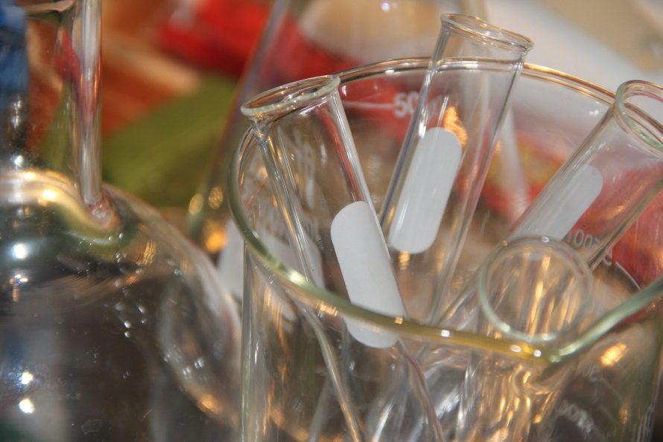
Most laboratory work is safe to conduct in some sort of glass apparatus. That is great news since glass is resistant to most chemical attack; notable exceptions being strong hot bases and, most definitely, hydrofluoric acid and some fluorides which will wreck your glassware outright. Another selling point is that glass has a high melting point. If for some reason you must run a reaction at excessively high temperatures, most glassware will only deform, but some types of glass will shatter. Be aware of this when heating any of your glassware of which you are not certain of its quality (See 2.1a for a discussion on Pyrex glassware). Another feature of glass is that it is amorphous, in other words, lacking a crystalline structure. For this reason, glass is clear, easily allowing you to see reactions taking place inside the vessel. Some glassware even allows for measuring using graduation marks found on the outside.
In addition, glassware is convenient for storing reagents for long periods of time, carrying out complex refluxing and reactions, crystallizing and purifying chemicals, precise solution standardization and, last but certainly not least, simple and fractional distillation under varying conditions. Glassware versatility allows for it to be the containment choice for nearly every chemist in almost every situation. For this reason, nearly all chemists will have a stockpile of glassware.
There are many types of common glassware including beakers, flasks, tubes, test tubes, funnels, pipettes, graduated cylinders and watch glasses. There are also more exotic (and more expensive) glassware products including separatory funnels, ground glass jointed distillation flasks, pressure-equalizing addition funnels, and jacketed condensers. We will explain the purpose of some of the more common glassware found in the home Chemist’s lab.
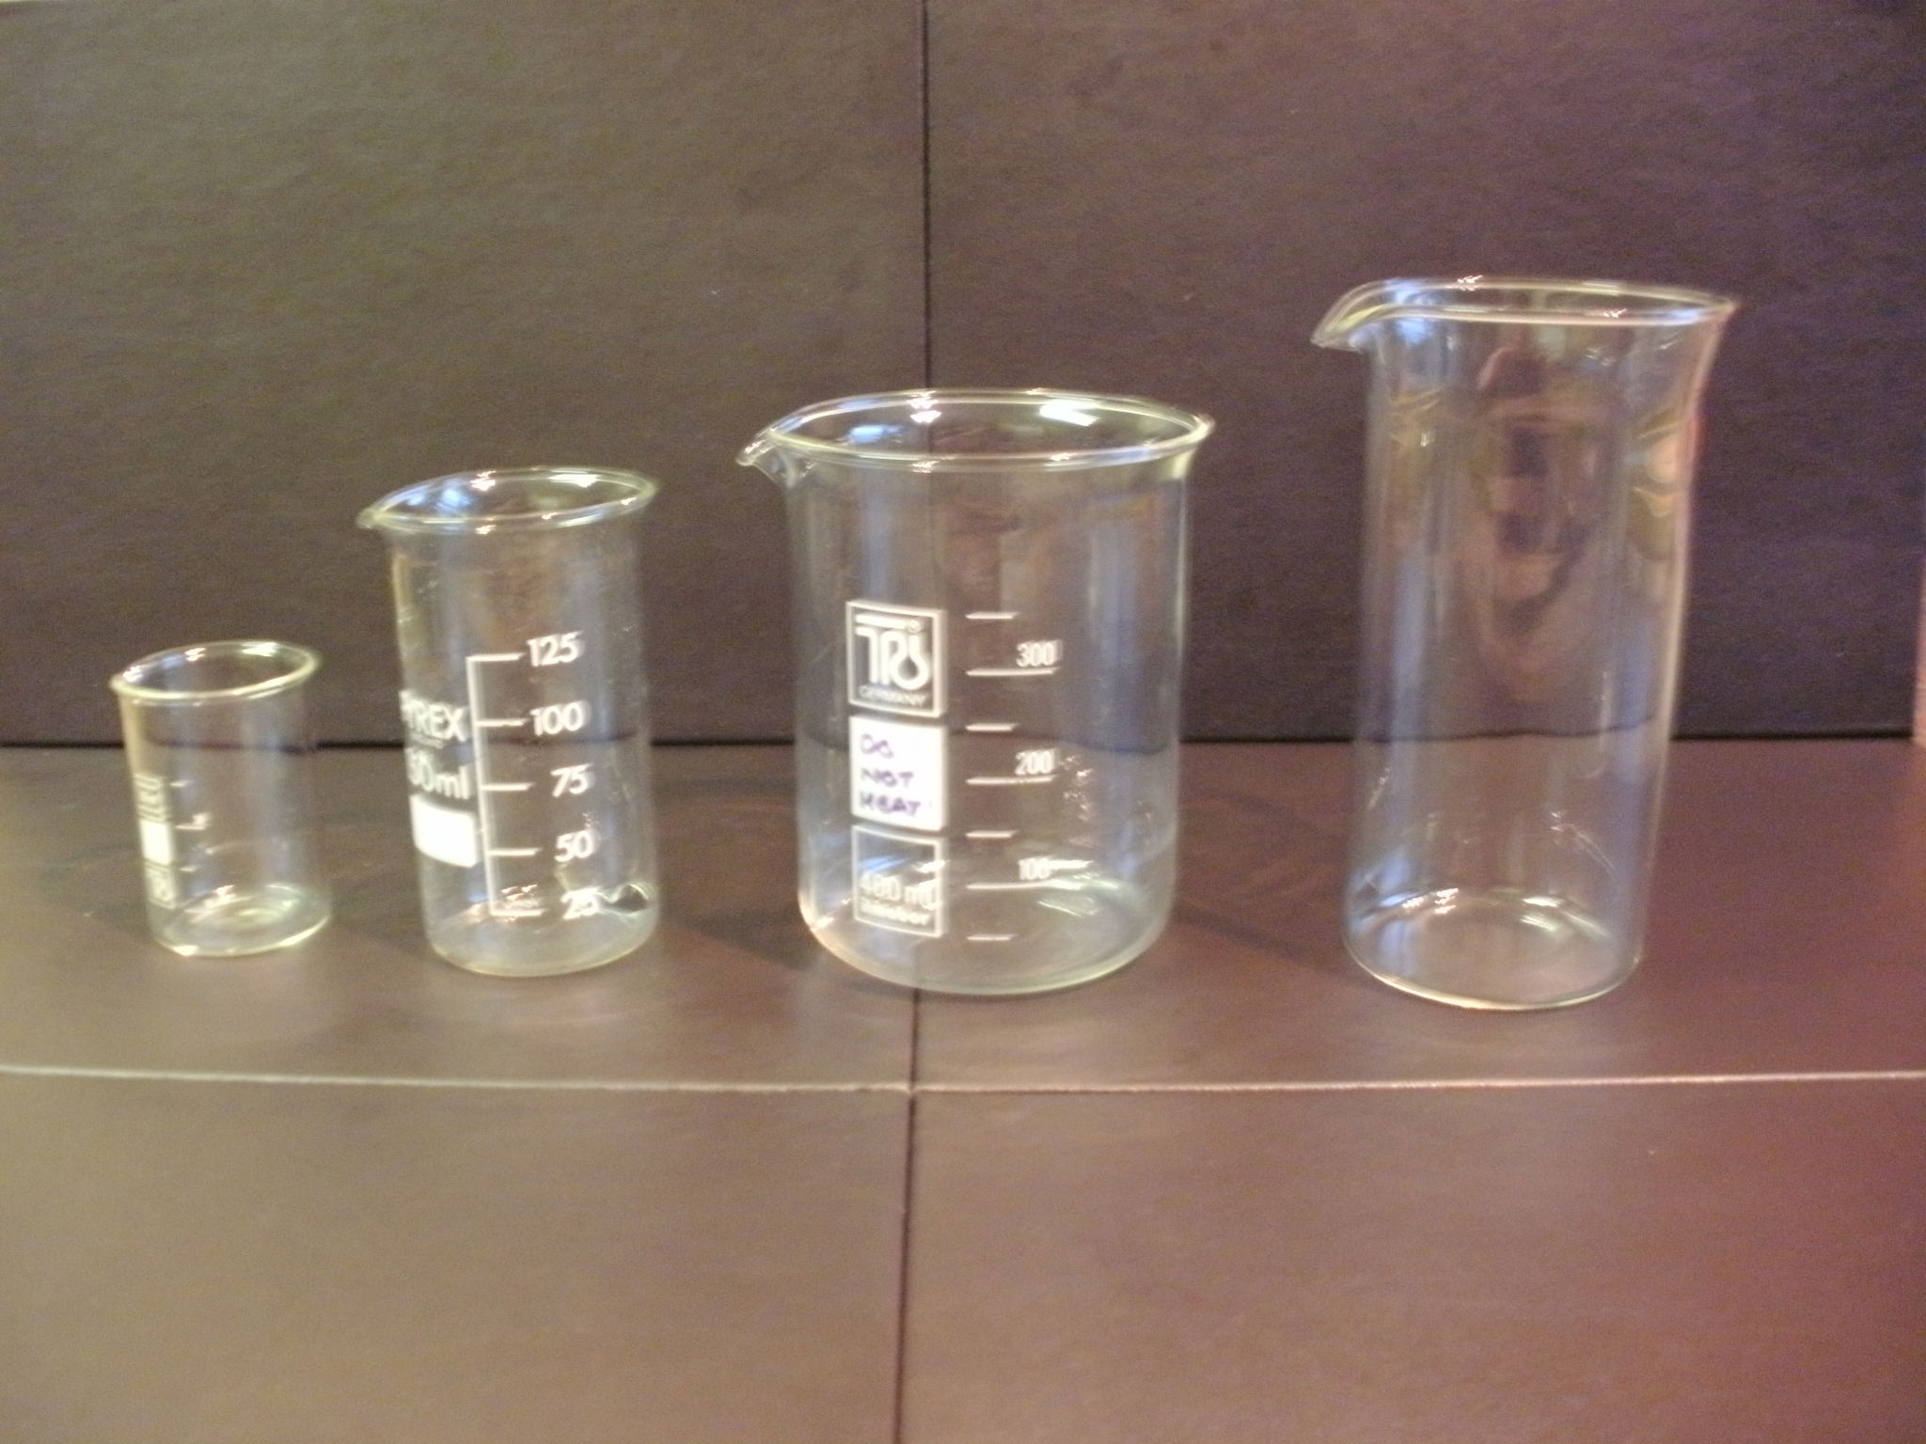Beakers: These are simple cylinders with a pour spout on the lip and a flat bottom. Many times, beakers have graduations on the side, but be warned, these volumes are not as accurate as those from graduated cylinders. Beakers are primarily used to mix or dissolve substances, but can also be used as simple heating vessels, oil or ice bath containers, and as a container to store chemicals, provided the beaker is properly covered in some way.
Florence Flasks: There are two main types of flasks; Florence flasks (sometimes called boiling flasks) and Erlenmeyer flasks. Florence flasks have a couple different names based on their shape, but normally have a round body with one or more necks in varying locations. Some have round bottoms and some have flat bottoms. Round bottomed flasks need stands to hold them up, 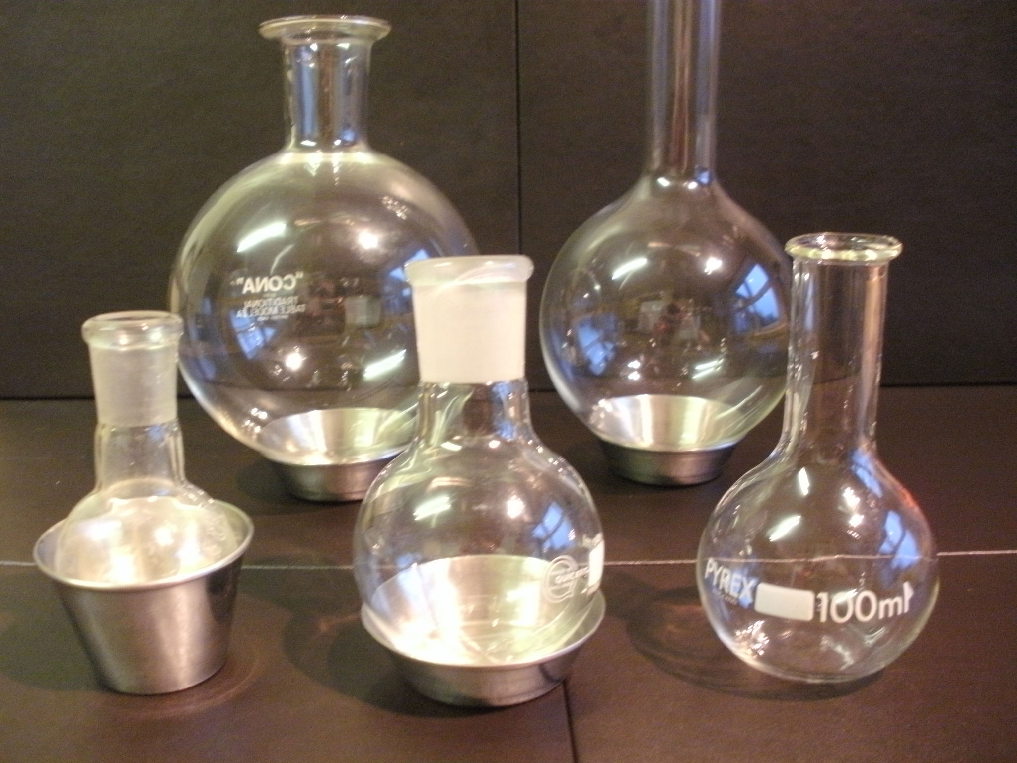but tend to be much stronger so that you can equip a vacuum without fear of implosion. Flat bottomed flasks are perfect for boiling solutions since they have a large surface area to contact your heating source. Volumetric flasks are precisely manufactured Florence flasks with a flat bottom and a very long neck. They have a calibration line for an accurate volume of liquid and provide the means of analytically producing a solution of known molarity. They come in varying sizes and of varying accuracy. Volumetric flasks are integral in the process known as standardizing.
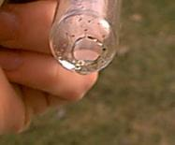
Erlenmeyer flasks: These have a cone-like body, wide at the bottom, narrow at the top, and are used for simple heating. The fact that they have narrow mouths allows them to act as their own ‘reflux condenser’ of sorts when heating a substance. Thus, they are ideally suited for recrystallization and to contain hot solutions that you do not want to simply boil down. When they have a side nipple, they are classified as filter flasks and are well suited for vacuum filtration.
Glass Tubes: Tubes are simply glass cylinders. Some are made of Pyrex, but most made of soda glass. By melting and blowing over a flame, the home chemist can make simple equipment to help with an experiment. For example he could wrap a cooking thermometer made of metal in glass to increase its chemical resistance or make a simple gas drying tube. Also, it is ideally suited to forming glass connections between separate flasks in order to bubble gases into a reaction. Be aware that Pyrex tubing must be melted with an oxygen rich flame.
Test Tubes: Test tubes are simply tubes with a rounded bottom and a lip made of Pyrex or soda glass. Small reactions can be run in them as well as being used for storing small amounts of chemicals. For example, a small bit of potassium metal could be stored in oil in a test tube properly sealed at the top. As an important safety note, because the bottoms are rounded, they are susceptible to breaking or cracking by being dropped. This can lead to hazardous spills of liquids everywhere. Care should also be taken when using stirring rods, as they can accidently puncture holes in the bottoms of test tubes.
Funnels: Funnels come in many different sizes, types, and composition; however, they all share the same conical shape. The most common material for funnels if glass and plastic. Funnels are primarily used to add liquids or powders into a small opening, such as the mouth of a test tube or a small flask. In addition, funnels can be used for filtering; in fact, there are specific types of funnels that are solely used in filtration. There is the Hirsch funnel, which is typically much 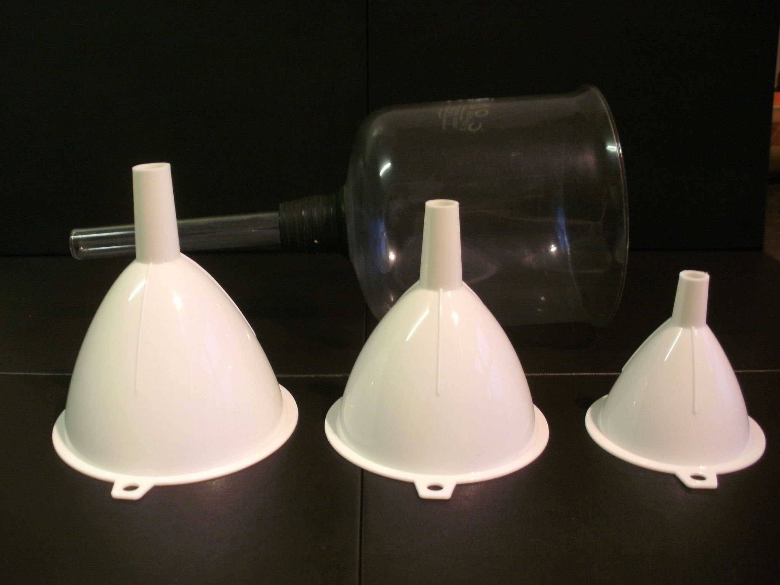narrower, with a small area for a filter paper to fit into and the Buchner funnel which is generally larger and requires a much larger piece of filter paper. Also, there are glass fritted filters that behave similarly to the previous two; however, it does not require filter paper due to the frit. Of course, if these are too elaborate for your needs as a home chemist, you can always just use gravity filtration through a plain funnel and some filter paper, depending on the mixture you are trying to separate.
Pipets: Pipets are tapered, glass tubes with a small hole at one end and a larger hole at the other. There are several different types of pipets. Some have the ability to deliver very accurate volumes of liquid. Others are used simply for transferring liquids. The precise volumetric ones are often made of glass, ranging in their class of accuracy. Transfer pipets can be made of glass or plastic and are usually disposable. When pipetting, never pipet by mouth; always use a rubber pipet bulb to draw up liquid.
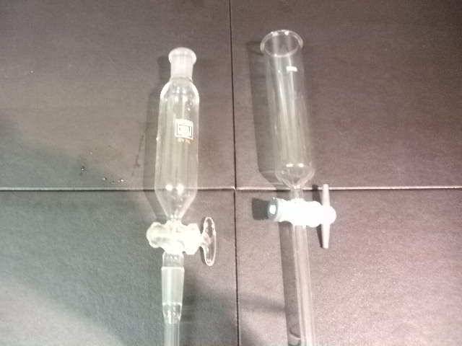Graduated Cylinders: These are simply large tubes with graduation marks along the sides, typically used for measuring relatively accurate volumes. They are by no means as precise as the volumetric pipets, but they are quicker, more versatile, and much cheaper. They come in all sizes and are typically made of either glass or plastic. 100mL graduated cylinders are the most common and versatile size and, for that reason, are highly recommended for the starting home chemist.
Watch Glasses: These are curved, dome-like pieces of glass that can be used to hold powders, cover beakers and flasks, or make "cold fingers" for sublimation purification of compounds such as iodine.
2.1a Advanced Glassware
Addition funnel: This piece of equipment has a stopcock at one end and an opening at the other to fill with reagents. The addition funnel provides a consistent drip rate to ensure a slow and controlled addition of a chemical to a reaction. Separatory funnels can be used as addition funnels (see below).
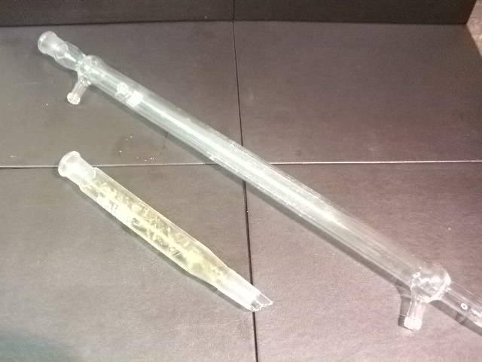Condenser: These are pieces of glassware that look like a tube inside of a tube. The inner tube can spiral, be straight, or even have bulbs. But, the outer tube is almost exclusively a piece of glass that has two nipples to allow water flow through one and out the other. There are exceptions to this in more elaborate pieces of glassware. Condensers are used for numerous applications. The most basic being a vapor condenser in a distillation setup. The water flowing through the outside jacket keeps the tube cool and forces the vapor to condense and drip down to a receiving flask. Condensers can also be used for refluxing a reaction. The same principles previously stated apply here as well. As the reaction proceeds, usually at a higher temperature, the solvent will start to evaporate. If you have to keep a reaction refluxing for several hours, or even several days, losing solvent is not a good thing, forcing you to add more and usually filling your workspace with vapors. A condenser connected to the setup will prevent this by forcing the solvent to condense and fall back into the flask. See section 3.1 for more on refluxing.
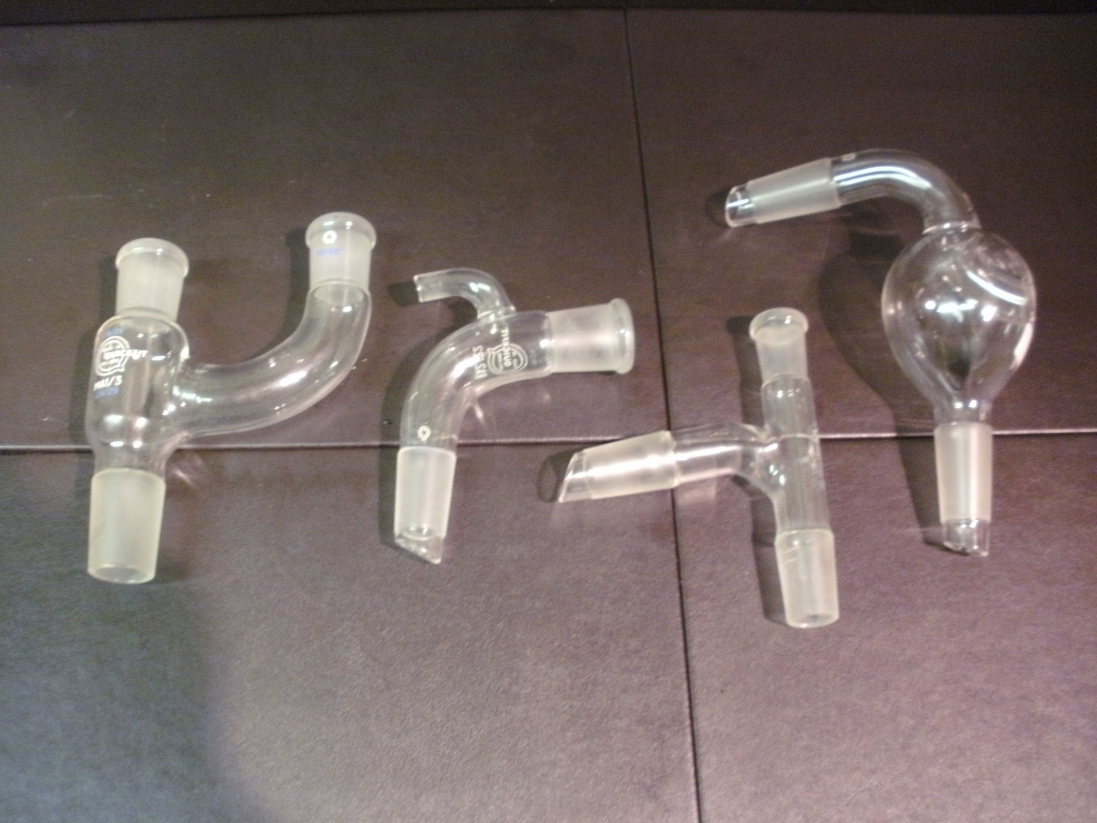Adapters: There are many different adapters used in distillation. We will discuss just a few of them here.
Thermometer Adapters: These are T-shaped pieces of glassware, typically jointed at a 105º angle, that can connect a flask at the bottom to a condenser on the side. The top joint fits a thermometer so you can monitor vapor temperature.
Claisen Adapter: This piece of glassware is similar to a thermometer adapter, except the piece that connects the condenser is curved upwards. This can be used to place a drip funnel above the reaction vessel, allowing for distillation to continue up the curved arm while adding a reagent. There are different types of this adapter as well, each used for a specific purpose.
Vacuum Take-Off Adapter: These are found at the end of distillation setups, connected to the condenser, as a drip arm and also to allow for vacuum distillation. Please see section 8.6 for information on this advanced technique.
Columns: This piece of glassware is used as a tube directly attached to the reaction vessel. The column allows for more surface area contact during distillation to increase the overall separation. The column can even be packed with glass or other inert material to further increase surface area. These range from a simple tube, to air jacketed columns, to Vigreux columns. Vigreux columns are glass tubes that have been indented and are fantastic tools for distillation.
There are also columns for a separation technique known as chromatography. This is a very advanced technique and is quite difficult to perform in a home lab, for now, columns will refer to the distillation columns.
Separatory Funnel: Similar to addition funnels, these have a stopcock at one end to control flow and an opening at the top to add a solution. The difference is that these are typically pear shaped and do not have graduations on the sides. These are used during a technique known as extraction to separate two immiscible layers. An example of this would be a mixture of hexane and water. The two solvents are insoluble in each other and form distinct layers. Please see chapter 8 for additional information on extractions.
2.1a Pyrex/Borosilicate Glassware
"Pyrex" is a brand of high quality borosilicate glass but the name is used to refer to all sorts of heat resistant glass. Borosilicate glass is simply the type of glass that most high quality lab ware is made out of. The most notable difference between Pyrex and normal soda lime glass is that Pyrex has a high percentage of boric oxide in the mix which reduces its expansion during heating. It has been shown time and time again that some of the cheaper glasswares, made by companies like Bomex, typically show less resistance to heating and repeated usage. Keep this in consideration when purchasing glassware of unknown origin, as some of it will be worthless for Chemistry. Pyrex and Kimax are good mid-priced glassware, while Duran is by far the top quality.
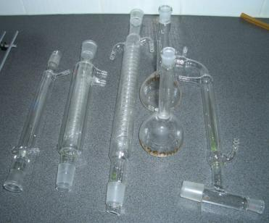
From left to right: Liebig condenser, two different styles of Graham coil condensers, two volumetric flasks, and a distillation head/condenser/vacuum take-off combination piece
Although any piece of glassware can have ground glass connections, they appear almost exclusively on borosilicate glass. Ground glassware is classified by the standard taper size of the flask’s opening. The larger diameter opening is called the female end and a smaller diameter opening, which is frosted, is called the male end. The male end fits snuggly into the female end, with the area of their connection ground with acid to give a tight connection. There are several different sizes of this type of glassware, each having its own merit in the lab.
A Note from the Authors
Never assume that your glassware is Pyrex or other another heat resistant type, back in my early days, I was planning to boil down about 400ml of CuCO3 in water. At that time I did not have a nice hotplate like I do now so I tried to use the stove. I grabbed a cooking bowl made of glass and poured the greenish mess into it. I then placed it on the stove and started stirring it when after a few minutes it cracked into about four parts. The nasty stuff got all over the oven and dripped onto the floor and the range area. A thousand thoughts started to rush through my head. "CuCO3 + HCl stomach acid --> Death?" I cleaned like a cheap animation on a laserdisk stuck in fast forward.
Don't assume all glass is Pyrex without checking first!
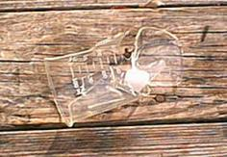
Glassware breakages are inevitable and happen to even the most experienced Chemist. How often it happens depends on a number of things: the kind of reactions you do, the environment you work in, and most importantly, how careful you are when you run experiments. But, when your glassware does break, it can still be useful. It can be kept and broken further in order to fill fractionating columns. Normally, these are filled with Pyrex beads, but broken glassware works just as well. These beads are outrageously expensive, costing over $100 to fill. Another fantastic use for broken Pyrex is as boiling stones. It can help form nucleation points, facilitating even boiling, especially in test tubes. The possibilities for broken glassware are unlimited and Pyrex is not something a chemist should throw away lightly. Keep this in mind the next time your favorite flask bites the dust.
However, it goes without saying that broken glass shards are sharp and should be handled with the utmost care. Wear gloves and slow down when you are using it; always store in a safe place to prevent accidental spillage.
A Tip from the Authors
Ground glass joints are occasionally subject to a process called freezing, usually caused by some foreign substance lodged between the joints. The glassware effectively becomes fused and now you are faced with the daunting task of separating the joints. It should be noted that a chief cause of this problem arises from storing strong bases in glassware. Hydroxide can get into the ground joint and actually dissolve some of the glass. In any case there are a number of steps you can take to free your glassware:

- Soaking the joint for several hours or even days might help. Water is a good first choice since it dissolves most salts. Basic or acidic solutions can be helpful for specific culprits. Lastly, organics, such as ethanol, or stronger non-polar solvents could also free the joint.
- Next try gentle heating with a blow dryer. Attempt to twist the two pieces back and forth while heating. Be sure to wear gloves, since the glassware will get deceivingly hot, very quickly.

The above steps should be done first, because the following processes have a greater possibility of cracking and damaging the glassware:
- Try tapping the glassware with rubber at the joints after heating.
- Try cooling the joints in a freezer, ice bath, or even with dry ice.
- Heat with a Ni-Cr wire.
- Use a torch.
Hopefully, you will succeed in getting the glassware unfroze. If you manage that, you should take some fine steel wool and gently go over the joint again to free it from any clinging particulates and be sure to clean it well before using again.
Don’t get discouraged, this process affects even the best Chemists as well.

A Tip from the Authors
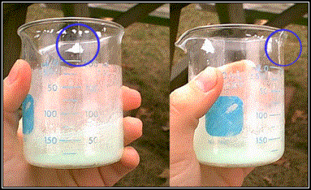
Cracks may be difficult to see when looking straight on at an object.
Before heating any borosilicate glassware, it is good to check it carefully for defects. Cracks and pits, known as stars, can lead to catastrophic failure at high temperature due to the expansion of the glass along the fractures created. Although it is not something to worry about compulsively, if you are using your glassware over high heat containing any corrosive, oxidizing, or hazardous solutions, do yourself a favor and give your glassware a quick check over for defects. This can easily prevent hazardous situations from occurring due to glass failure.
2.1b Soda-Lime
This is the type of glassware is probably most familiar to you and common in your daily life. If an item is made out of glass and there is no need to heat it, it is probably some composition of soda-lime. The number one advantage of soda-lime, over all other types of glassware, is the low cost of production. It is a fairly inert, transparent material with a very good cost to usage ratio. It is for this reason that jars, drinking glasses, vases, and light bulbs are made from it. Well, all this is fine for everyday usage, but what about using it for Chemistry? Let’s look at the advantages of soda-lime:
• Resistant to most chemicals (Exceptions are hydrofluoric acid, fluosilicic acid, concentrated phosphoric acid, or hot/concentrated bases)
• Cheap and widely available
• Electrical insulator (Can be a good thing or a bad thing)
So, if all of these are true, it seems that soda-lime should be preferred for chemical glassware. However there is one big flaw that deters its use in Chemistry:
Soda-Lime glass is not meant to be heated!
Aside from gradual heating in a water bath or just for very short periods, this rule should NOT be tested. Soda-lime is terrible at conducting heat; one part of the glass will try to expand while the other parts will not. This stress causes hairline cracks, usually unnoticeable until it is too late.
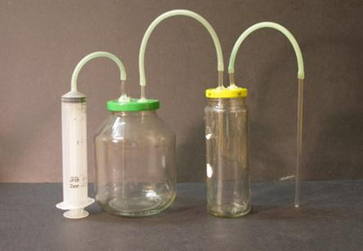
An example of acceptable soda-lime glass usage is pictured to the left. This setup is used for washing gasses. Note that the glass components are regular jars and are surprisingly well suited for this purpose, since the temperatures and pressures involved are not great. It should also be noted that the glass tubes being used are soda-lime as well. Glass tubing is widely available as either soda-lime or borosilicate. The differences between the two are less noticeable than for glassware. Both can be heated over an open flame where they can be bent into a number of shapes suiting your purpose.

Provided that you do not heat soda-lime glass, it can still perform well for heatless reactions. It also provides a cheap and effective means for liquid or solid reagent storage. However, it should also be noted that aqueous solutions should not be stored in soda-lime, or any other glass container, if there is the possibility of freezing. The expansion of the liquid as it freezes can and, often will, crack and destroy the container. Nevertheless, soda-lime does have its place in the home lab; just be sure to heed the authors’ warnings when using it.
2.1c Lead Glass, Vycor, Misc.
Vycor™, also known as fused silica or vitreous silica, is the holy grail of glassware. Composed entirely of SiO₂ fused together at high temperature, it is very resistant to thermal shock. In addition, it is even more chemically resistant than glass and can be heated to nearly 1200°C, since it does not soften until 1500°C. This would be the preferred way to go for many chemical vessels. The big problem is that its manufacturing process is quite complex and, therefore, the products are exorbitantly expensive and difficult to acquire. The most common use of fused silica is in the form of a crucible for use in a furnace. They are typically not clear, but an opaque, white color. These crucibles are great for burning samples for analysis. The cheapest source of fused silica for the home chemist is found from online jewelry supply stores. They sell small fused silica crucibles for the explicit purpose of melting precious metals, such as gold, within the average jeweler’s shop. They are often shaped in such a way as to allow direct heating and are thus suitable for melting or burning pretty much anything. The jeweler’s crucibles are also considerably cheaper than those intended for laboratory use.
There are also a number of specialty glasses found on the free market not listed here. A specific example is leaded glass. It is known for being highly dense and having a refractive color on cut surfaces. Its use is mainly ornamental and should not be used for Chemistry. This is due to the high probability of solutions leeching a portion of the lead, ruining most reagents and creating a heavy metal problem. The same holds true for Vaseline glass. This light green glass is also used for ornamental purposes and can be found in antique glassware. The pigment in the glass is uranium oxide which could also be leeched with acids.
The key point here is that unknown types of glass should not be used for Chemistry purposes. Although they may look aesthetically pleasing, some types of glassware may cause harm to the chemicals contained within them.
2.1d Cleaning Glassware
It should be your goal at the end of the day in the lab to make sure that you clean your glassware. Dirty glassware can result in inaccurate measurements, catalyze decompositions, destroy glassware, and ruin reactions. Plus, cleaning dirty glassware in the middle of an experiment is time consuming and can lead to failed reactions because you had to wander off to clean the glassware. In addition, you better hope water doesn’t hurt the reaction; otherwise you will have to spend time drying it too. The best solution to this issue is to clean it after you use it.
Oftentimes, cleaning glassware is as easy as rinsing out the contents with tap water and quickly rinsing with distilled water. After that, the glassware can be allowed to air dry. However, cleaning organic compounds requires a little bit more care. In most laboratory settings, organic compounds are initially rinsed out with acetone and then water. This combination works well, as the acetone removes and dilutes the concentrations of insoluble organics, but is itself soluble in water. It’s a fantastic solvent for this purpose. Of course, other organic solvents like toluene or xylene work too, but they will not be simply washed out with water at the end and should not be disposed of down a drain.
Sticky grime left in glassware is best removed by brute strength and elbow grease. Scrubbing with a cloth or using brushes are an effective means of removing sticky materials. This can also save you the hassle of trying to find the perfect solvent to dissolve the compound. This method can even remove solvent rings. Hard to reach spots can be scrubbed with an pen, bent at the middle and used to wipe a piece of paper towel around along the inside. If this does not work, usually it will make it smear or just plain not rub off. Then you will have to start to analyze the situation. Is the stain organic? If it is, try and use some acetone or ethanol. Next, try soaking with an acid to attempt reacting the compound. A step up from here is to try sodium hydroxide in ethanol or isopropanol and let that soak about an hour. Do not let it soak longer, since this mixture can attack ground glass joints and ruin volumetric glassware. If that doesn’t work, boiling nitric will oxidize even carbon to CO₂ which should clear up nearly any mess you can make. It goes without saying that boiling nitric acid is dangerous; please use caution if it should come to this.
There are other mixtures available for thorough cleaning too. A mixture of acidified potassium dichromate (usually with sulfuric acid) is a tried and tested method. But, be aware, that chromium in the +6 oxidation state is a known carcinogen.⁽¹⁾ Also, this is a strong oxidizing agent and can set fire to some organics. Another powerful method uses a mixture of concentrated sulfuric acid with strong hydrogen peroxide solution. This solution is known as Caro’s Acid, or “Piranha Solution”, and is a very strong oxidizing solution. It is the authors’ recommendation to avoid this, since it can explode from contact with some organics. Another safer alternative might be Fenton’s Reagent⁽²⁾ which is made by adding a soluble iron salt to a solution of peroxide and mildly acidifying. This can take some time but it will remove most stains. There are many other solutions available including pre-packaged alternatives, many of which involving hydrogen peroxide or solid peroxides such as sodium perborate.
At the very least, these methods should loosen stains which will allow you to fall back on physical methods to remove crusted material. Some things, however, are irremovable. These include pitting, etching, and chipping; these may look like stains at first glance, but the physical damage is permanent. In these cases, the glassware should take up a reduced work load and be retired from continuous use.
(1) | It is this carcinogenic property of this solution of potassium dichromate in sulfuric acid that has caused it to fall out of use in many labs. Prepared solutions of this in the home lab may have solid CrO₃ precipitated at the bottom as a brick red solid, this is a very strong oxidizing agent capable of igniting ethanol vapors, take care.
(2) | For more information on Fenton’s Reagent try http://www.h2o2.com/applications/industrialwastewater/fentonsreagent.html
2.2 Plastics
Plastics are great as storage containers. Nearly all plastics can store non-oxidizing/non-dehydrating/non-reducing aqueous solutions. Such as water, hydrochloric acid, dilute sulfuric acid, or sodium hydroxide solutions. This is the preferred storage medium for many bases and inorganic salt solutions. There are many different types of plastic, often differentiable by an inscribed designation, usually found near the recycling number. Once you know what kind of plastic you have, additional possibilities open up as to what you can store in it. For example, some plastics become soft and dissolve in acetone, whereas acetone may be purchased in containers made from a different type of plastic. Here are the common types of plastic containers in America:
Polymer Name and Abbreviations | Generalized Properties
Polyethylene Terephthalate PETE or PET
High-density Polyethylene HDPE
Polyvinyl Chloride or PVC
Low-density Polyethylene LDPE
Polypropylene PP
Polystyrene PS
2.3 Ceramic
Ceramics are the preferred piece of equipment in high heat application and are generally quite cost efficient. They are also somewhat resistant to acids and dilute bases. One common laboratory item made of ceramic is the Buchner funnel. In terms of over the counter ceramic lab ware, flower pots provide an effective means for limited heating. While they cannot withstand extreme temperatures, for example, thermite will destroy the cheaper ones, flowerpots can be used as a crude crucible. It should be noted that some of them are high in magnesium oxide and these are in fact capable of withstanding high temperatures. These pots, usually with a drainage hole in the bottom, are much better suited for the thermite reaction. Upon ignition, the liquid metal can drip into molds to cast simple objects.
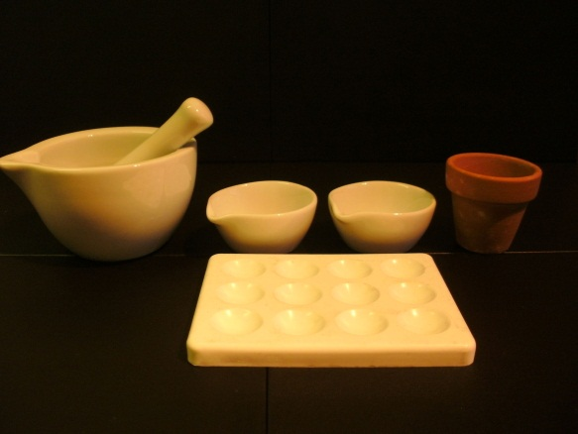
Flower pots are by far on the cheaper end of the ceramics spectrum, that being said, over the counter ceramic ware does get significantly more expensive from here. One of such is the ceramic plate used in high end bullet proof vests. Another is the innumerable ceramic membranes available that find use in electrolysis and reverse osmosis. These items are typically out of the price range of the home chemist. This is why ceramic pots are favored since they are readily available and, if they break, are very cheap. Not only are the magnesium oxide pots fantastic for thermite, they can also function as arc furnaces and as reaction vessels for high temperature reductions.
2.3a Ceramic Production
Before discussing various aspects of high temperature furnaces and other equipment, it is helpful to understand how ceramic are actually made.
1) Nomenclature:
Ceramics are primarily composed of metal oxides, such as aluminum oxide (Al₂O₃), silicon dioxide (SiO₂), calcium oxide (CaO), etc. Commonly, metal oxides are named by removing the suffixes, –um, –ium, or –on, and replaced with –a. A few examples are alumina, zirconia, silica, and calcia. Ceramics can also be composed of more complex mixtures, such as kaolin, a type of large grained clay with the chemical formula Al₂O_{3*}2SiO_{2*}2H₂O. It is much easier to name this with its common name than its –a name.
2) Acid, Neutral, and Basic compositions:
Ceramic compounds fall into these three broad categories. Where R represents a metal and O represents oxygen, chemicals with the formula R₂O and RO are bases or fluxes (eg calcia), chemicals with the formula R₂O₃ are neutral compounds (eg alumina), and chemicals with the formula RO₂ are acids or glass formers (eg silica). At high temperatures, fluxes attack acids by lowering their melting point, and together, form a glass. Soda lime glass, for instance, is easily melted in a furnace because of the large amounts of soda and lime, whereas pure silica is much harder to melt. Neutral compounds do not flux other compounds and are not easily dissolved by fluxes, with some exceptions such as boria (B₂O₃). While glass is great for making household glass items, borosilicate glass and pottery glazes, in the furnace itself, glass is an undesirable product.
3) Green strength:
Clay particles will adhere to one another when wet and dried, but most particles will not. If clay is used, the ceramic will probably not need another binder, but if pure alumina, for example is used, some sort of binder will also be needed to keep the powder together until it has heated enough to form a ceramic bond.
4) Firing:
Ceramic objects and ceramic bonds are created by high temperature firing of powders. The powders are usually slip-cast, pressed, or extruded into the shape needed, and then dried and heated. At high temperatures the mobility of molecules and ions within ceramic objects increases, and eventually gain enough mobility to diffuse across various grains of the ceramic powder, fusing the separate grains into one monolithic object. This is a ceramic bond created by what is informally known as solid state sintering. As the grains fuse together, they shrink towards one another, decreasing the porosity of the ceramic object. Another type of bond that occurs is called liquid state sintering. Here, some of the components of the mixture melt into a glass, which envelops the non-melted particles, and begins to dissolve them. Eventually the solution saturates, and sometimes higher melting point crystals form within the solution, also knitting the ceramic together.
2.4 Teflon ®
Teflon®, is the brand name of a polymer produced by Dupont named PolyTetraFluorEthylene or PTFE for short. A Dupont researcher accidentally discovered this compound when he noticed there was no more pressure on his vessel, which contained tetrafluorethylene gas. He found a snow-white condensation product, which proved to have exceptional chemical resistance.

Teflon is the top choice for chemists due to this resistance and relative inexpensiveness. The only problem with Teflon is that it is a thermoplast and weakens when overly heated. Compared to usual plastics its heat resistance is far higher, it can be safely employed between -200°C and +250°C. Another noteworthy fact is that Teflon is insoluble in every solvent below 300°C. Teflon should never be exposed to temperatures above 400°C, because it will decompose into several fluorocarbon molecules which can severely damage your health.
Because of the exceptionally strong fluorine-carbon bond, Teflon resists the most aggressive chemicals, including fluorine gas or ozone. The only applications where it can't be employed are those where it comes into contact with very strong reducing agents and molten hydroxides. Due to the fluorine content, Teflon can act as an oxidizer in these special circumstances. As a bit of a frightening side note, the United Sates Air Force uses Teflon/Mg flares (although hard to ignite) to distract heat seeking missiles because they burn hotter than an aircraft exhaust. You have been warned.
Teflon is used in conjunction with many different types of glassware. The simplest examples of this is the stopcocks in burettes and separatory funnels and also some stoppers. These are simply Teflon versions of their glass counterparts. The advantage being that they are not subject to freezing up like glass joints do. They also seem to provide a better fit and are easier to clean in this author’s opinion.
Teflon is available over the counter mainly as tape, for sealing pipe joints in plumbing, and as sheets for baking without the use of grease. Teflon tape (if it's pure, it should be white) is a very good substitute for joint grease because it won't contaminate your distillate, yet it provides good sealing. Teflon tubing is available on the internet and in other places and is a great choice for leading around halogens in their gas phase. Many baking sheets are also coated in Teflon, but are most likely impure. It is, however, the material of choice for applications where elevated temperatures are needed. As a side note, some baking sheets are made out of ICFLON, an unknown proprietary compound.
2.5 Refractory Compositions
Refractory compositions possess an even higher degree of heat resistance then any compound mentioned thus far, except some ceramics into which they overlap. For examples of refractory compositions please see the section 8.4 on working with refectories.
2.6 Metals
As with all these other reaction vessels, metals have their own niche were they work the best. The actual value of a metal vessel is of course directly related to the metal’s properties. Below are a few examples of metal reaction vessels:
Metal | Working Temperature | Chemical Resistance | Additional Properties | Obtained From
Nickel (Ni) | 900 C | Very highly resistant to alkali conditions, resistant to non-oxidizing acids | Can be used to handle fluorine or other halogens. | Nickel can be bought in the form of crucibles from chemistry suppliers
Iron (Fe) | 1200 C | Iron will dissolve in acids readily; however is it somewhat more resistant to alkalis. It also oxidizes easily. | Iron oxide that forms on the surface of objects adheres loosely flaking off and leading to further oxidation. | Iron end caps for plumbing are cheap and readily available. The shiny end caps are galvanized and have a thin layer of zinc plated on them.
Stainless Steel | 1000 C | More resistant to acids and bases then iron alone. Less easily oxidized in general. | Can cause hard to determine contamination with reactions due to its varying compositions. | Mixing bowls, measuring cups, and other kitchen containers can often be found to be made of stainless steel.
Copper (Cu) | 775 C | Somewhat resistant to acids (No resistance to nitric acid), equally resistant to bases; better then iron; slightly better than stainless. | Forms soluble highly colored contaminates. Clean before every use due to oxidation by air. Can be used with fluorine or other halogens. | Copper end caps are available for plumbing; they are perfect for amateur experimenting.
Tin (Sn) | 250 C | Weak against acids and bases. | Tin forms an oxide coating when exposed to concentrated oxidizing agents that can prevent it from reacting further. | Unknown; tin cans actually only have an insignificant tin coating, therefore they do not convey the properties of tin entirely.
Aluminum (Al) | 550 C | Very weak against acids and bases. | Forms a tenacious oxide coating that prevents further oxidation in strong oxidizing conditions such as HNO3 >75% | Aluminum end caps and pipes are available in larger home improvement stores. Soda cans work for this as a cheap alternative.
Silver (Ag) | 700 C | Strong against acids and bases. | -NA- | Expensive and hard to find; used for work with hydrazine.
Platinum (Pt) | 1200 C | Very resistant to most anything | -NA- | Very, very, expensive; platinum vessels for chemistry are hard to come by.
As a brief conclusion, there are many different vessels used in the field of Chemistry. The preferred type depends on the reaction composition and conditions under which it is performed. When glass just cannot handle a reaction there are many alternatives. Remember to always do your research before carrying out a reaction or that nice stainless steel pot could end up as a pile of useless slag.

